Ref: WP2-TSD | Issue Date: 08/11/2026 | Version Number: 1.0
Contract REPORTNET 02020400/2004/394786/MAR/G3

TECHNICAL specificationS DOCUMENT
for
WEB DAshboards service

Written by:  EUROPEAN DYNAMICS S.A.  Mr. Nedeljko Pavlovic | Sign Off and Date:  08/11/2026 |  | Appraisal Authority:  EEA  Mr. Stefan Jensen | Sign Off and Date:
Verified by:  EUROPEAN DYNAMICS S.A.  Dr. Zack Protogeros | Sign Off and Date:  08/11/2026 |  | Appraisal Authority:  EEA | Sign Off and Date:
Approved by:  EUROPEAN DYNAMICS S.A.  PROJECT MANAGER  Dr. Stelios Papastratos | Sign Off and Date:  08/11/2026 |  | Appraisal Authority:  EEA | Sign Off and Date:

Circulation List

Name | Company/Institution
Nedeljko Pavlovic | EUROPEAN DYNAMICS S.A.
Zack Protogeros | EUROPEAN DYNAMICS S.A.
Stelios Papastratos | EUROPEAN DYNAMICS S.A.
Stefan Jensen | EEA
Soren Roug | EEA
Jan Bliki | EEA

Document History

Ver. | Date |  | Confidentiality | Description | Action | Pages
1.0 | 15/04/05 | Normal |  | Release to EEA | C | 59
(*) Action: I = Insert; R = Replace; C = Creation

Table of Contents
Table of Contents 3
Table of Figures 4
References 5
Document conventions 5
1 Introduction 6
1.1 Purpose 6
1.2 Scope 6
1.3 Overview 6
2 Decomposition description 7
2.1 Layer decomposition 7
2.1.1 Presentation layer 8
2.1.2 Business logic layer 8
2.1.3 Enterprise resources abstraction layer 8
2.1.4 Enterprise resources layer 8
2.2 Module decomposition 9
2.2.1 Web module 9
2.2.2 Admin module 10
2.2.3 Users module 11
2.2.4 Channel server module 12
2.2.5 Data access module 12
2.2.6 DTO module 12
2.2.7 Utility module 12
2.3 Data decomposition 13
2.3.1 EEA User 13
2.3.2 EEA Role 13
2.3.3 Channel 14
2.3.4 Dashboard 14
2.3.5 Transformation 14
2.3.6 Visible element 14
2.3.7 EEA Users Channel 15
3 Dependency description 15
3.1 Intermodule dependencies 15
3.2 Data dependencies 16
3.2.1 Mapping Procedure 16
3.2.2 Additional remarks 17
4 Interface description 17
4.1.1 Web module 18
4.1.2 Admin Module 18
4.1.3 Users Module 18
4.1.4 Channel server Module 18
4.1.5 Data access module (DAO) 19
4.1.6 DTO module 21
4.1.7 Utility module 22
5 Detailed design 22
5.1 Modules detailed design 22
5.1.1 Web module 22
5.1.2 Admin module 24
5.1.3 Users module 27
5.1.4 Channel server module 29
5.1.5 Data access module 32
5.1.6 DTO module 36
5.1.7 Utility module 38
5.2 Data detailed design 40
5.2.1 Database schema 40
6 Deployment view 45
Appendix A - Interactions diagrams 47

Table of Figures
Figure 1 - REPORTNET Web Dashboards Service modules and dependencies 9
Figure 2 - The WDS ER diagram 13
Figure 3 - The Receiver and Feed web modules class diagram 23
Figure 4 - The Channel Server management module class diagram 24
Figure 5 - The Dashboard profiles management module class diagram 26
Figure 6 - The Users module class diagram 27
Figure 7 - The Channel Server module class diagram 29
Figure 8 - The WDS DAO overall structure 32
Figure 9 - The WDS Hibernate DAO realization class diagram 33
Figure 10 - The WDS LDAP DAO realization class diagram 34
Figure 11 - The DTO module class diagram 36
Figure 12 - The Utility module class diagram 38
Figure 13 - The WDS Database physical data model diagram 41
Figure 14 - The WDS Deployment diagram 45
Figure 15 - Create new channel sequence diagram 48
Figure 16 - Create dashboard profile sequence diagram 49
Figure 17 - Push RDF data to the WDS sequence diagram 50
Figure 18 - Pull RSS/RDF data from the external web service sequence diagram 50
Figure 19 - View dashboard sequence diagram 51

References
Title | Author | Version | Date | Location
Call for Tenders No ENV.G.3/SER/2003/0116 "Technical specifications for the provision of information technology services to support the development of a wider REPORTNET"
Kick-off Meeting Minutes (24/01/2005) | Stelios Papastratos | 1.1 | 08/02/2005 | http://eea.eionet.eu.int/Members/irc/eionet-circle/eionet-telematics/library?l=/reportnet_project/specialist_files/wp01/reportnet-mom-050124-kom/_EN_1.1_&a=d
Development Procedures | Soren Roug | 1.0 | 25/01/2005 | http://eea.eionet.eu.int/Members/irc/eionet-circle/eionet-telematics/library?l=/reportnet_project/specialist_files/wp01/kickoff-rougppt/_EN_1.0_&a=d
List of Questions/Answers - Zope/Python-J2EE Comparison | Nedeljko Pavlovic  Stelios Papastratos | 1.0 | 31/01/2005 | http://eea.eionet.eu.int/Members/irc/eionet-circle/eionet-telematics/library?l=/reportnet_project/specialist_files/wp01/reportnet-wd-kom-v002doc/_EN_1.0_&a=d
Web site design guidelines | EEA |  | 2004 | http://www.eionet.eu.int/software/design
Functional Specifications document | Nedeljko Pavlovic | 1.1

Document conventions

Acronyms/Abbreviations:

JSP - Java Server Pages
EEA - European Environment Agency
TSD - Technical Specifications Document
EIONET - The European Environmental Information and Observation
Network
HTTP - Hypertext Transfer Protocol
REQ - Each requirement is uniquely identified by a REQ and an
appropriate sequence number
RDF - Resource Description Framework
RSS - Really Simple Syndication
SMTP - Simple Mail Transfer Protocol
TCP/IP - Transmission Control Protocol / Internet Protocol
XML - Extensible Mark-up Language
XML-RPC - Remote procedure calling using HTTP as the transport protocol
and XML as the encoding protocol.
XMPP - Extensible Messaging and Presence Protocol
UI - User Interface
WDS - Web Dashboards Service

Introduction

Purpose
A Technical specifications document (TSD) is a representation of the software system that is used to facilitate analysis, planning, implementation, and decision making. This Technical specifications document (TSD) refers to the REPORTNET Web Dashboards Service.

Scope
The objective of the Web Dashboards Service is to provide key stakeholders in international environmental reporting with dashboards presenting summary information harvested from REPORTNET modules, as well as from other Agency systems based on predefined profiles. The service will improve cooperation and transparency and ease retrieval of information from REPORTNET.

Overview

The structure of the document is as follows:

Section 2 (Decomposition Description) offers several views on how to decompose the total structure of the REPORTNET Web Dashboards System. The system can be decomposed in four different views:

- Layer decomposition;
- Module decomposition
- Concurrent process decomposition
- Data decomposition

In terms of layer decomposition the system is decomposed in the following layers:

- Presentation layer
- Business logic layer
- Enterprise resources abstraction layer
- Enterprise resources layer

In terms of module decomposition the system is decomposed in the following modules:

- Web Module (belongs to the presentation layer)
- Admin Module (belongs to the business logic layer)
- Users Module (belongs to the business logic layer)
- Channel Server Module (belongs to the business logic layer)
- Data access module (belongs to the business logic layer)
- DTO module (belongs to the Enterprise resources abstraction layer)

Section 3 provides information about Intermodule and data dependencies. Section 4 provides a description of the interfaces for the various modules. Section 5 presents the detailed design of each module.

Decomposition description
This section offers several views on how to decompose the total structure of the REPORTNET Web Dashboards system. Emphasis will be placed on general layering, modularity, processes, and the general structure of data.

Layer decomposition
The REPORTNET Web Dashboards Service logical partitioning consists of application layers that collaborate together through well-defined interfaces, but do not share internal knowledge about each other. This not only makes the structure and design of the WDS easier to understand, but it also has scaling implications. Since each layer communicates with the one below it using well-known interfaces, it is a simple matter to replace any one of the layers as long as the new layer presents an identical interface.
The WDS consists of the layers described below:

Presentation layer
The presentation layer handles the layout, formatting, and display of query results to users. This layer provides views of data to users of the WDS. The WDS presentation layer is concerned only with providing a user interface that enables the WDS users to interact with the system.

Business logic layer
This layer implements most of the REPORTNET Web Dashboards Service functions, which has the overall control of collecting data from the external resources and their classification. Furthermore, this layer provides a software representation of objects that users deal with when interacting with the WDS throw User interface.

Enterprise resources abstraction layer
This is an object abstraction layer wrapping the enterprise resources. In the WDS design model, Java Beans are normally used.

Enterprise resources layer
This layer comprises non-Java resources storing raw data. It consists of MySQL Database, OpenLDAP and File system.

For each module described in the following 2.2.1 section the layer in which the module is placed will be pointed out.

Module decomposition

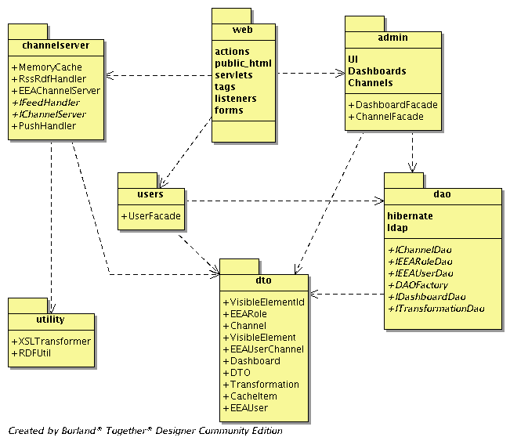
Figure 1 - REPORTNET Web Dashboards Service modules and dependencies

Web module
The Web module represents the conceptual module that contains all objects related to the WDS user interface, as well as objects that make interaction between the WDS and users and between WDS and external web services possible. This is where information is presented after it has been processed by the back-end layers of the application. The Web module allows WDS users and external web services to experience the system's output based on the previous requests they have made and allows them to issue new requests in order to exploit the functionalities offered. Moreover, we will split this module in more conceptual modules as described in the sections below.
This module, as well as its leaf modules, belongs to the REPORTNET Web Dashboards presentation layer. Section 5.1.1 presents the detailed design of the WDS Web module.

Admin Web module
The administration user interface will allow EIONET Administrators access to administrative functions of the WDS. The following list represents functions that will be accessible through the administrative user interface:
- Channel server management.
- Dashboard profiles management
- UI templates management

User’s Web module
The graphical user interface will allow EIONET Users to access the WDS functionalities responsible for the following tasks:
- Choosing of desired dashboard profile and specifying initial presentation parameters
- Customizing layout of the portlets presented on the dashboard
- Specifying presentation of data related to dashboard specific portlets

Common Web module
The common user interface will expose functionalities common to all users that may access the WDS web site. The following list represents these functions:
- Login
- Access to links related to other REPORTNET web services

Receiver web module
The Receiver Web module will expose functionalities used for pushing data to the WDS through the XML-RPC protocol. Section 5.1.1.1 presents the detailed design of the WDS Receiver Web module.

Feed web module
The Feed Web module will expose channels data in the RDF form to the external web services. Section 5.1.1.2 presents the detailed design of the WDS Feed Web module.

Admin module
The admin module is a conceptual module that contains core functionalities related to the EIONET Administrator
This module and its leaf modules belong to the REPORTNET Web Dashboards business logic layer.

Channel server management module
This module provides functionalities related to channel server management. It will provide the following functions:
- Creation of new channels. Through these channels the channel server will get the feed provided by external web services.
- Editing of existing channels
- Removal of channels
This module belongs to the REPORTNET Web Dashboards business logic layer. Section 5.1.2.1 presents the detailed design of the WDS Channel server management module.

Dashboard profiles management module
This module will provide functions to manage the dashboards profiles. The following functions are provided by this module:
- Creation of new dashboard profile
- Editing of existing dashboard profile
- Removal of dashboard profile
This module belongs to the REPORTNET Web Dashboards business logic layer. Section 5.1.2.2 presents the detailed design of the WDS Dashboard profiles management module.

UI templates management module
This module will provide core functionalities related to the management of the of basic design elements of the WDS User interface. The functions provided by this module are the following:
- Edit WDS UI footer
- Edit WDS UI Header
This module belongs to the REPORTNET Web Dashboards business logic layer.

Users module
This module will provide services related to the EIONET Users. Core functions it will provide are:
- Choose desired dashboard profile
- Set a user specific basic parameters for dashboard
- Define user specific presentation attributes for the each portlet presenting one content channel
- Define user specific layout of the portlets presenting dashboard channels
This module belongs to the REPORTNET Web Dashboards business logic layer. Section 5.1.3 presents the detailed design of the WDS Users module.

Channel server module
The Channel Server module contains core functionalities for harvesting EIONET feeds, their caching and processing. It will provide the following functions:
- Harvesting of events
- Receiving of events
- Transformation Service which will perform the following tasks:
  - Transformation of RSS feeds into RDF format by using XSLT
  - Transformation of the collected data by using predefined style-sheets
  - Generic transformation of the collected data by using predefined metadata elements and RDF parser.
- Cache service
This module belongs to the REPORTNET Unified Service business logic layer. Section 5.1.4 presents the detailed design of the WDS Channel server module.

Data access module
The Data access module provides functions that are responsible for accessing the raw data and assembling this raw data to the software objects. The following list represents the module functions:
- Access to the data LDAP server
- Access and manipulation of data stored in the WDS Database server
- Wrapping raw data into the Java objects (Java beans)
This module belongs to the REPORTNET Unified Service business logic layer. Section 5.1.5 presents the detailed design of the WDS Data access module.

DTO module
This module contains classes providing object representation of the WDS data entities. All its classes provide methods for manipulation of their attributes. This module belongs to the REPORTNET Web Dashboards Service business enterprise resources abstraction layer. Section 5.1.6 presents the detailed design of the WDS DTO module.

Utility module
The Utility module wraps core functionalities provided by the following external libraries:
- Jena RDF parser
- Xalan-J XSLT engine
Also this module will provide functionalities for the synchronization of the credentials data between the WDS and LDAP server.
This module belongs to the REPORTNET Unified Service business logic layer. Section 5.1.7 presents the detailed design of the WDS Utility module.

Data decomposition
The data handled in the WDS consist of a few real world entities. These entities are described here conceptually. Therefore, this section contains a conceptual model of all data entities, which can then be readily translated into a database schema .The Database Schema will be presented in the section 5.2.1. The following figure represents the WDS logical data model.

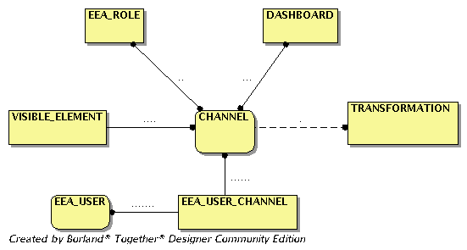
Figure 2 - The WDS ER diagram

EEA User
An EEA user is an individual who has been registered in EEA’s LDAP server.
- ExternalUserId: Unique identifier of the user used in the EEA LDAP server; currently, it is the username.
- Dashboard: The Dashboard which EEA User chose to view accessing the WDS.
- NumberOfColumns: A number representing the actual number of columns on the dashboard page where portlets will be placed.
- PageRefreshDelay: A number representing the interval for automatic refresh of the EEA User dashboard view.

EEA Role
EEA Users are grouped in EEA Roles in accordance to their privileges.
- ExternalRoleId: Unique identifier of the user used in EEA LDAP server; currently, it is the role name.

Channel
A channel is an entity used for defining how data will be provided from an external web service to the WDS.
- Title: The title of the channel.
- Description: The description of the channel.
- FeedUrl: The URL of the external feed in case that channel will work in ‘PULL’ mode.
- Mode: A term representing the working mode of the channel. It is allowed to be ‘PUSH’ or ‘PULL’.
- RefreshDelay: This attribute is related to channels that will work in ‘PULL’ mode. It represents the number of seconds that need to expire before a new pulling for the channel occurs. The default value will be 60 seconds; needed for channels that will work in pull mode.
- UserSpecific: A logical value representing if this channel is related to EEA Users. If it is related to the EEA Users channel, content will be filtered and presented only for the EEA User that is accessing the dashboard.
- Transformation: Represents the XSL used for generating the channel presentation layout.
- Transformation: The dashboards where a channel belongs.

Dashboard
A dashboard is a core concept of the WDS. It consists of the channels which will show up on the WDS web site.
- Name: The name of the dashboard.
- Description: The description of the dashboard.
- Channels: The list of channels which the dashboard contains.

Transformation
The EEA Administrators will be able to define these entities in order to provide custom presentation rules for a specific channel.
- Name: The name of the transformation.
- Description: The description of the transformation.
- Content: Text representing the XSL that is going to be used for generation of the channel view.

Visible element
A meta-data element pulled or received from the external web service supposed to be presented on dashboards.
- Channel: The channel for which the property will be shown.
- Property: The element that is going to be showed on the dashboards.
- SortOrder: A number representing the sort order of the visible element. If it is NULL the element does not participate in data sorting at all. If it is n>0 then data will be sorted as (E1, E2… En, En+1…)

EEA Users Channel
This entity is used for the manipulation of the channels presented on the EEA User dashboard.
- Channel: The channel which will be shown on the EEA User dashboard.
- EEAUser: The user for whom WDS will store the channel presentation data.
- CordX: A number representing the column on the user’s dashboard view at which the channel will appear.
- CordY: A number representing the row on the user’s dashboard view at which the channel will appear.

Dependency description

Intermodule dependencies
The REPORTNET Web Dashboards Service modules depend on the following list of external java libraries:

- Apache Struts framework version 1.2.4
- Apache Xerces-J version 2.6.2
- Apache Xalan-J version 2.6.0
- Apache XML-RPC version 2.0
- Hibernate version 3.0.2
- MySQL-connector version 3.1
- Apache Log4J version 1.2.9
- Jena version 2.2
- EEA ACL API current version

The following modules rely on other modules that are part of the REPORTNET Web Dashboards Service:

- Web Module. This module depends on the Admin, Users, Channel server and DTO modules. Moreover, this module depends on the Apache Struts framework libraries and the Apache XML-RPC libraries. Conceptually this dependence represents the connection between the WDS presentation and the business logic layer.
- Admin Web module. This module uses the Admin module in order to accomplish tasks requested by the EIONET Administrators. It also depends on the DTO module in order to provide data to the underlying business logic.
- Users Web module. This module uses the Users module in order to accomplish tasks requested by the EIONET Users. It also depends on the DTO module in order to provide data to the underlying business logic.
- Common Web module. This module uses the EEA ACL API in order to authenticate and authorize users.
- Receiver Web module. This module uses the Channel Server module in order to push data to the WDS provided by external web services.
- Feed Web module. This module uses the Channel Server module in order to retrieve data of the specified channel. It also depends on the DTO module in order to obtain the results provided by the underlying business logic.
- Channel server management module. This module depends on the Data access, DTO and Utility modules.
- Dashboard profiles management module. This module depends on the Data access and DTO modules.
- Data access module. This module depends on the DTO module. It also depends on the Hibernate external library.
- Utility module. In order to achieve its functions the Utility module uses the Jena, Apache Xalan-J and Apache Xerces-J external libraries.

Data dependencies

Mapping Procedure
The mapping of the conceptual domain model to the database schema will be constructed using the following rules:
- Every concept should correspond to at least one entity.
- Attributes are mapped directly if they represent a type of attributes that is native to the MySQL 4.1 Database System.
- Attributes that refer to concepts in the domain model are mapped to a foreign key attribute that uniquely identifies the entity in the schema.
- If the relationship between entities has a many-to-many nature this relationship is expanded into a separate table, where both foreign keys are united as the primary key of the relation.

Additional remarks
The REPORTNET Web Dashboards service is going to support EEA Roles and EEA Users kept on the EEA LDAP server. The WDS channels definitions depend on EEA Roles since one or more roles will be assigned to each channel in order to support restrictions on channels viewing for specific EEA roles. Since each user will be able to define the layout of channels on his/her dashboard the WDS also depends on EEA Users. These entities are going to be kept in the WDS Database. However, a question raised here is how the lifecycle of the EEA Roles and the EEA Users on the EEA LDAP server will reflect on the WDS. The WDS system design tackles this question by the following approaches:
- If a user wants to select some dashboard profile the WDS will check for the existence of the EEA User in the WDS Database. In case the user does not exist it will be created.
- Since the selection of desired dashboard depends on the Dashboard profiles, as well as on Channels, the best place for handling the EEA Roles is in the management of the dashboard profiles and in the channels management. When an EIONET Administrator accesses any of those two management sections the WDS will contact the EEA LDAP server and perform a synchronization of the EEA Roles between the WDS Database and the LDAP server.
- It is possible that the WDS functions described in (2) will not be executed by for some longer time. So synchronization of data will also take place on each user’s invocation of the dashboard view. In order to avoid affecting WDS performance the EEA LDAP data, as well as the WDS database roles and user data will be cached and synchronized upon identification of changes.

Interface description
This subsection describes everything designers, programmers and testers need to know in order to use correctly the functions provided by the WDS modules. It includes the details of the internal interfaces not provided in the REPORTNET Web Dashboards Service Functional Specifications Document.

Web module
The interface to the REPORTNET Web Dashboards Service WEB module and all its leaf modules is provided by the Tomcat application server. The WEB module will be accessed by the EEA users, as well as by external web services.

Admin Module

Channel server management module
The interface to the Channel management module is provided by the public methods of the ChannelFacade class. The Administration WEB module uses this interface.

Dashboard profiles management module
The interface to the Dashboard profiles management module is provided by the public methods of the DashboardFacade class. The Administration WEB module uses this interface.

Users Module
The interface to the Users management module is provided by the public methods of the UserFacade class. The Users WEB module uses this interface.

Channel server Module
The interface for this module is determined by the IChannelServer java interface.
The WEB, Users and Admin module use this interface. EEAChannelServer class implements this java interface.
IChannelServer interface is defined as follows:
- getChannelContent(Channel channel)
Returns an instance of the DTO class containing parsed or transformed RDF channel content.
- push(Channel channel, String rdf)
Pushes RDF formed data through the specified channel to the WDS.
- invalidateChannelCache(Channel channel, int type)
Invalidates the channel server cache for the specified channel. The parameter type determines how cache is going to be invalidated.
- regusterChannel(Channel channel)
Creates new the WDS channel.

Data access module (DAO)
The interface for this module is determined by the IChannelDao, IDashboardDao, ITransformationDao, IEEARoleDao, IEEAUserDao java interfaces, as well as by the DAOFactory abstract class. The Users, Admin and Channel server module use these interfaces.

The DAOFactory interface is defined as follows:
- getDAOFactory(int type)
Returns an instance of the concrete Dao Factory class according to the provided type. The WDS will implement Factories for DB and LDAP access by using the Hibernate framework. The abstract factory approach allow the WDS to be extended by an unlimited number of concrete factories (for an example Documentum, Oracle IFS, etc.)
- getEEAUserDao()
Returns the Data access object responsible for user data manipulation.
- getEEARoleDao()
Returns the Data access object responsible for role data manipulation
- getChannelDao()
Returns the Data access object responsible for channel data manipulation.
- getDashboardDao()
Returns the Data access object responsible for dashboard profile data manipulation.
- getTransformationDao()
Returns the Data access object responsible for style-sheet data manipulation.

The IEEAUserDao interface is defined as follows:
- createUser(EEAUser user)
Creates a new EEAUser and stores it in data storage as determined by the DAO Factory.
- removeUser(EEAUser user)
Removes the existing EEAUser from the data storage as determined by the DAO Factory.
- updateUser(EEAUser user)
Updates the existing EEAUser in the data storage as determined by the DAO Factory.
- findUser(EEAUser user)
Retrieves the existing EEAUser from the data storage as determined by the DAO Factory. Querying of the data storage will be executed by using the id or the externalId provided inside the user parameter.

The IEEARoleDao interface is defined as follows:
- createRole(EEARole role)
Creates new a EEARole and stores it in data storage as determined by the DAO Factory.
- removeRole(EEARole role)
Removes the existing EEARole from the data storage as determined by the DAO Factory.
- updateRole(EEARole role)
Updates the existing EEARole in the data storage as determined by the DAO Factory.
- findAllRoles()
Retrieves the all existing EEARoles from the data storage as determined by the DAO Factory.
- findRole(EEARole role)
Retrieves the existing EEARole from the data storage as determined by the DAO Factory. Querying of the data storage will be executed by using the id or the externalId provided inside the role parameter.

The IChannelDao interface is defined as follows:
- createChannel(Channel channel)
Creates a new channel and stores it in data storage as determined by the DAO Factory.
- removeChannel (Channel channel)
Removes the existing channel from the data storage as determined by the DAO Factory.
- updateChannel (Channel channel)
Updates the existing channel in the data storage as determined by the DAO Factory.
- findAllChannels()
Retrieves the all existing channels from the data storage as determined by the DAO Factory.
- findChannel (Channel channel)
Retrieves the existing channel from the data storage as determined by the DAO Factory. Querying of the data storage will be executed by using the attribute id provided inside the channel parameter.

The IDashboardDao interface is defined as follows:
- createDashboard(Dashboard dashboard)
Creates a new dashboard profile and stores it in data storage as determined by the DAO Factory.
- removeDashboard (Dashboard dashboard)
Removes the existing dashboard profile from the data storage as determined by the DAO Factory.
- updatDashboard(Dashboard dashboard)
Updates the existing dashboard profile in the data storage as determined by the DAO Factory.
- findAllDashboards()
Retrieves the all existing dashboard profiles from the data storage as determined by the DAO Factory.
- findDashboard(Dashboard dashboard)
Retrieves the existing dashboard profile from the data storage as determined by the DAO Factory. Querying of the data storage will be executed by using the attribute id provided inside the dashboard parameter.

The ITransformationDao interface is defined as follows:
- createStylesheet(Transformation transformation)
Creates a new XSL style-sheet and stores it in data storage as determined by the DAO Factory.
- removeStylesheet(Transformation transformation)
Removes the existing XSL style-sheet from the data storage as determined by the DAO Factory.
- updateStylesheet(Transformation transformation)
Updates the existing XSL style-sheet in the data storage as determined by the DAO Factory.
- findAllStylesheets()
Retrieves the all existing XSL style-sheets from the data storage as determined by the DAO Factory.
- findStylesheet(Transformation transformation)
Retrieves the existing XSL style-sheet from the data storage as determined by the DAO Factory. Querying of the data storage will be executed by using the attribute id or the attribute name provided inside the transformation parameter.

Module interfaces will be used to allow interaction between system modules and interactions between external systems and the WDS. These interactions are presented on interaction diagrams in Appendix A

DTO module
The interface to the DTO module is provided by the public methods of all the DTO classes. All modules are using this module since its object will flow through the WDS application layers.

Utility module
The interface to the Utility module is provided by the public methods of the XSLTransformer, RDFUtil and LDAPUtil classes. All modules are using this module since its object will flow through the WDS application layers.

Detailed design

Modules detailed design
The section presents the internal details of each WDS module. These details include attribute descriptions for identification, processing and data. The section also contains the details that will be needed by the programmers for the relevant implementations.

Web module
The REPORTNET Web Dashboards web module is implemented with strict adherence to the MVC design pattern by using the Apache Struts framework. The Apache Struts framework is a set of cooperating classes, java servlets, and JSP tags that make up a reusable MVC design.
The individual components are as follows:
- Model. The Model is responsible for providing the data from the enterprise resources, saving the data into the data stores and for wrapping of business logic objects. Data entered by the user through View are checked in the model before submitted to the underlying business logic.
- Controller. The Controller receives the request from the browser and decides where to send the request. With Apache Struts framework, the Controller is a command design pattern implemented as a servlet.
- View. The WDS view represents the user view of the application and is responsible for taking the input from the user, dispatching the request to the controller and then receiving the response from the controller and displaying the result to the user. HTML, JSPs, Custom Tag Libraries and Resources files are the parts of the view component. There is no flow logic, no business logic, and no model information.

This section focuses on the Receiver web module and the Feed web module. Admin, Users and common web modules will be implemented as modules that are following the usual Struts implementation.
The following figure represents the Receiver web module and the Feed web module class diagram.

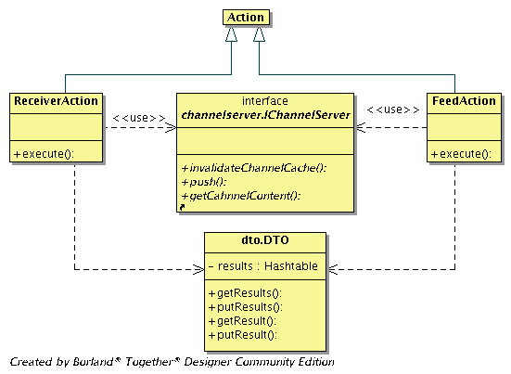
Figure 3 - The Receiver and Feed web modules class diagram

Receiver Web module
The Apache XML-RPC library is embedded into the WDS Web server framework that supports reading HTTP POSTs from an InputStream.

ReceiverAction class
This class extends the Struts Action class. It is responsible for the processing of requests received from the external web services that try to push data to the WDS.
Attributes:
Methods:
- execute(ActionMapping map, ActionForm form, HttpServletRequest request, HttpServletResponse response)
The WDS web server executes this method on an external web service XML-RPC call. This method will use the push method of the IChannelServer interface in order to push data to the WDS. At the end of execution it will flush the result containing the operation result to an external web service. The method expects from the external web service the desired channel identifier, as well as the RDF content that is going to be received.

Feed Web module
This class encapsulates the business logic of the WDS Channel server management module.

FeedAction class
Attributes:
Methods:
- execute(ActionMapping map, ActionForm form, HttpServletRequest request, HttpServletResponse response)
The WDS web server executes this method on an external web service call or by a user call (by using an Internet browser). The method expects the channel identifier to be provided in the request. It will use the IChannelServer method getChannelContent in order to retrieve the RDF data stored in the channel server memory cache. At the end it will flush the RDF content to the caller.

Admin module

Channel server management module

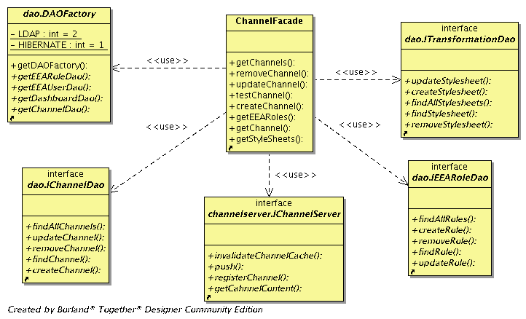
Figure 4 - The Channel Server management module class diagram

ChannelFacade class
This class encapsulates the business logic of the WDS Channel server management module.

Attributes:
Methods:
- getChannels()
Returns a list of all the WDS existing channels.
- removeChannel(Channel channel)
This method removes the channel specified by the channel parameter.
- getEEARoles()
Returns list of the all existing EEA roles.
- testChannel(Channel channel)
In case of PULL mode working channel this method tries to connect to the external web service and to retrieve metadata elements contained in the RDF stream.
- getStyleSheets()
Retrieves and returns list of the all existing the WDS style-sheets.
- createChannel(Channel channel)
Creates new WDS channel. It assumes that all needed data entities that are related to the channel are contained inside channel parameter.
- updateChannel(Channel channel)
Updates the existing WDS channel. It assumes that all needed data entities that are related to the channel are contained inside channel parameter.
- getChannel(Channel channel)
Retrieves and returns transformed content of the specified channel by calling EEAChannelServer method getChannelContent.

Dashboard profiles management module
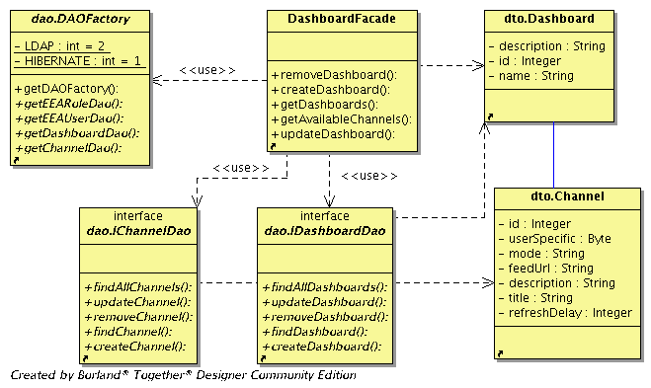
Figure 5 - The Dashboard profiles management module class diagram

DashboardFacade class
This class encapsulates the business logic of the WDS Dashboard profiles management module.

Attributes:
Methods:
- createDashboard(Dashboard dashboard)
Creates a new WDS dashboard profile by calling the IDashboardDao method createDashboard.
- removeDashboard(Dashboard dashboard)
Removes an existing WDS dashboard profile by calling the IDashboardDao method removeDashboard.
- updateDashboard(Dashboard dashboard)
Updates an existing WDS dashboard profile data by calling the IDashboardDao method updateDashboard.
- getDashboards()
Returns the List of all existing WDS dashboard profiles.
- getAvailableChannels(Dashboard dashboard)
Returns all channels that are not already assigned to the specified dashboard profile. If dashboard parameter is not provided at all then it returns all existing channels.

Users module

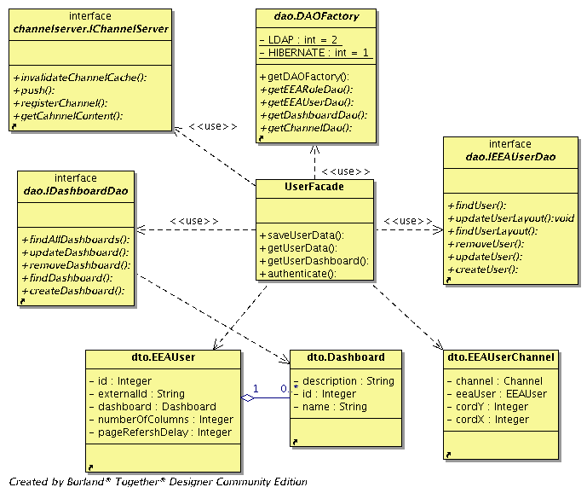
Figure 6 - The Users module class diagram

UserFacade class
This class encapsulates the business logic of the WDS Users management module.

Attributes:
Methods:
- authenticate(String username, String password)
Performs authentication of the user who specified the username and password parameters. This method performs authentication by using the EEA ACL API AuthMechanism class method sessionLogin.
- getUserDashboard(EEAUser user )
The first step this method performs is check of the user existence in the LDAP server. If the specified user does not exists anymore in the LDAP server he/she will be removed from the WDS. Cascade deletion takes place so all data related to the specified user are removed.
The second step involves querying the Channel server module for the dashboard channels data. The method then returns a list of the DTO objects containing channels content, as well as layout parameters for each channel.
- saveUserData(EEAUser user)
Updates data related to the user dashboard.
- getUserData(EEAUser user )
Retrieves and returns data related to specified user.

Channel server module
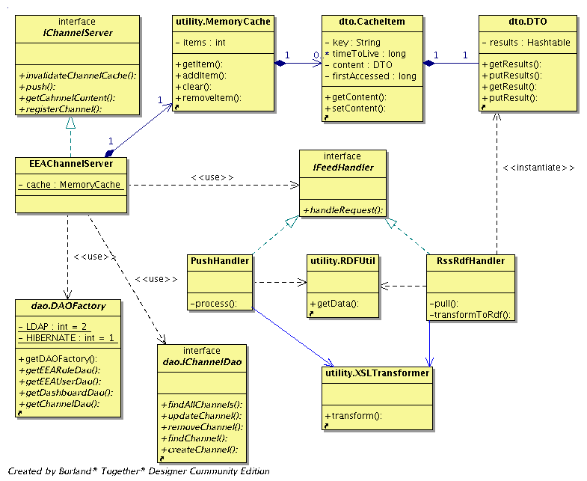
Figure 7 - The Channel Server module class diagram

EEAChannelServer class
This class implements the IChannelServer interface.

Attributes:
- cache
MemoryCache object that keep cached the WDS channels data.
Methods:
- getChannelContent(Channel channel)
A static method that returns an instance of the DTO class containing java beans representing items fetched from the external data source. If the specified channel works in ‘PULL’ or ‘PUSH’ mode the method will try to get data from the Channel serve memory cache. If the cache for the specified channel does not exist this means that it has not been retrieved from the external web service at all or that the item has been removed from the cache due to timeToLive expiration - in case of a channel working in ‘PULL’ mode. If cached channel does not exist inside the memory cache the Channel server will retrieve the data from the external web source, cache it and return it to the caller (possible only in case of ‘PULL’ mode). In case of operating in ‘PUSH’ mode it will return empty result since the WDS needs to wait the external web service to push data. Otherwise, the method will return data from the memory cache.
- push(Channel channel, String rdf)
This method handles RDF formed data pushed from an external web service to the WDS.
- registerChannel(Channel channel)
Creates new the WDS channel.
- invalidateChannelCache(Channel channel, int mode)
For the specified channel this method invalidates the Channel server memory cache. Invalidation can work in two modes.
  - CONTENT=2: Only invalidate parsed or transformed RDF content.
  - ALL=3: Invalidates all cached data for the specified channel.

RssRdfHandler class
This class represent one tier of the Channel server Chain of responsibility (COR) pattern implementation. Moreover, it represents the strategy responsible for fetching data from the external web services by using the HTTP protocol and RSS/RDF as the expected data format.

Attributes:
Methods:
- handleRequest(Channel channel, int type, MemoryCache cache)
This method is an essential part of the COR pattern. It will check the type of the provided channel by the channel parameter and invoke pulling of the data in case that type matches the type supposed to be handled by the RssRdfHandler class. Otherwise it will delegate the request to the next class in the chain if it exists.
- pull(Channel channel)
Pulls data from the external web service specified by the channel parameter. By using the HTTP protocol this method retrieves the RSS or RDF formed data. If it identifies the retrieved data as RSS it will convert it into the RDF form by calling the transformToRdf method. The next step this method performs is checking of how the pulled content shall be transformed. If the channel has an associated XSL, the method will invoke the XSL transformation on the RDF content and will store the result in the memory cache. If the channel does not have an associated XSL the method will parse the RDF and will store property-value pairs in memory cache. The original RDF will always be stored in memory cache. The reason for this is that an EIONET Administrator may change an XSL associated to the channel or even to switch between XSL and generic approach (property-value approach).
- transformToRdf (String rss)
By using a stored XSL it transforms the data provided to the RDF format and returns the result of the transformation.

PushHandler class
This class represent the second tier of the Channel server Chain of responsibility (COR) pattern implementation. Moreover, it represents the strategy responsible for processing of data pushed to the WDS.

Attributes:
Methods:
- handleRequest(Channel channel,int type, MemoryCache cache)
This method is an essential part of the COR pattern. It will check the type of the provided channel by the channel parameter and invoke pulling of the data in case that type maches the type supposed to be handled by the PushHandler class. Otherwise, it will delegate the request to the next class in the chain if it exists.
- process(Channel channel)
Processes received RDF data. The first step this method performs is checking of how received content shall be transformed. If the channel has an associated XSL, the method appends the received RDF content to the existing one, invokes the XSL transformation on the RDF content and stores the result in memory cache. If a channel does not have an associated XSL, the method parses the RDF and appends the property-value pairs in memory cache to the existing one. The original RDF will always be stored in memory cache. The reason for this is that an EIONET Administrator may change the XSL associated to the channel or even to switch between XSL and generic approach (property-value approach).
.

Data access module
The WDS data access module will be developed by adhering to the DAO pattern.
Its major purpose is manipulation with raw data stored in enterprise resources such Database and LDAP.
The following figure represents the overall structure of the WDS DAO pattern implementation.

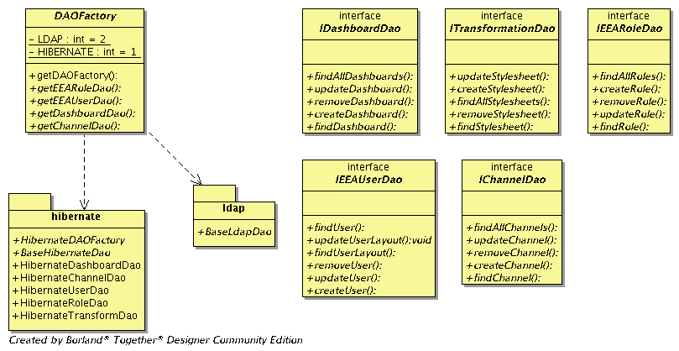

Figure 8 - The WDS DAO overall structure

The following class diagram represents the Hibernate DAO realization.
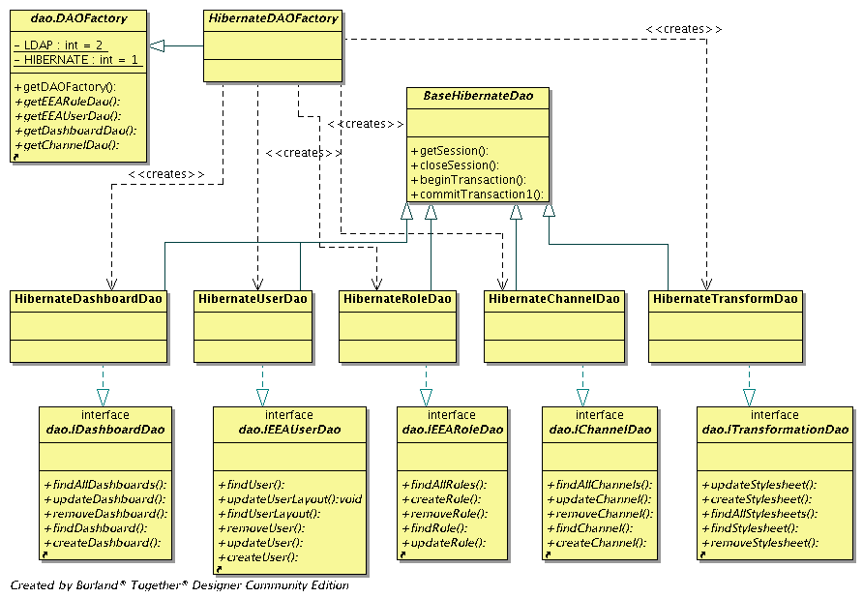
Figure 9 - The WDS Hibernate DAO realization class diagram

The Hibernate framework will be used for working with the WDS database. It provides all functions needed for persistence storage manipulation. Hibernate will be configured through its configuration file, as well as through mapping files.
We have already described the interfaces Hibernate DAO classes implement in section 4.1.5. Therefore, this section does not focus on these realizations and methods again. The implementation of these methods will be different for different factories but they will perform the same job as already described.
The Hibernate framework will perform all needed operations on the WDS database in accordance to the defined mapping files and the provided DTO classes. In this section we only need to stress how the WDS Data access module will use Hibernate. The answer is through the BaseHibernateDao class.

BaseHibernateDao
This class represents the basic class that will be inherited by all Hibernate DAO classes. The purpose of this class is to encapsulate all logic needed for accessing the Hibernate functions such as the creation of sessions, transaction management, generic loaders, etc.

Attributes:
Methods:
- getSession()
Returns a new Hibernate Session object that must be closed when the work has been completed.
- closeSession()
Closes the opened Hibernate Session.
- beginTransaction(Session session)
Begins the transaction related to the provided session
- commitTransaction(Transaction transaction)
Commits the given transaction.

The following class diagram represents the LDAP DAO realization.

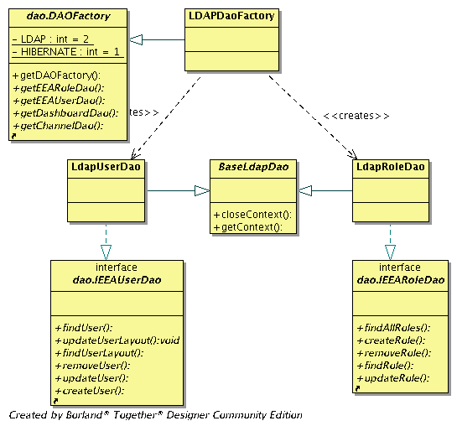
Figure 10 - The WDS LDAP DAO realization class diagram

Since the WDS will query the LDAP server only to retrieve information about roles and users the LDAP DAO will only implement the IEEARole and IEEAUser interfaces. This section does not focus on the realizations and methods already described in section 4.1.5.
We only need to stress in this section how the WDS Data access module will communicate with the LDAP server. The answer lies in the BaseLdapDao class.

BaseLdapDao
This class represents the basic class that will be inherited by all LDAP DAO classes. The purpose of this class is to encapsulate all logic needed for accessing the LDAP server, as well as the common LDAP functions.

Attributes:
Methods:
- getContext()
This method uses the JNDI/LDAP service provider to connect to the LDAP server and initializes its connection request controls
- closeContext()
Closes the opened JNDI context.

DTO module
Since the DTO module represents the object mapping of the data entities described in section 2.3 we will only specify classes that do not represent raw data. A common characteristic for all DTO module classes is that they have getters and setters methods for each attribute. Since those methods represent a basic java approach for manipulation of class attributes this TSD will not expand on them.
The DTO objects will allow us to transfer information between the different layers of the WDS.
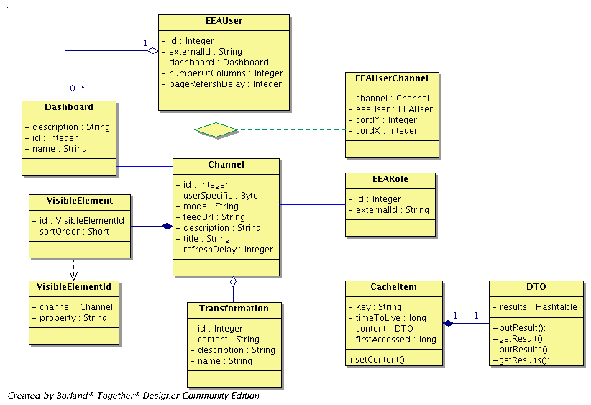
Figure 11 - The DTO module class diagram

CacheItem
This class represents a single item that will reside inside the WDS Memory cache.

Attributes:
- key
Represents the key of the cached item. In the WDS case it will be the channel unique identifier.
- timeToLive
A number representing how long an item will be in cache. It is measured in seconds.
- content
An instance of the DTO class representing the cached content.
- firstAccessed
A Java timestamp representing the time when an item was cached.
Methods:
- setContent(DTO content)
Sets the new content of the CacheItem object.
- getContent()
Returns a DTO object representing the cached content.

DTO
This class represents the universal Data Transfer Object that may be used for the various purposes. In the WDS it represents the general container for any type of data.

Attributes:
- results
Hashtable representing a placeholder for any data.
Methods:
- putResult(String key, Object value)
Adds to the container a new value with a specified key.
- getResult(String key)
Returns an Object representing result contained inside DTO and identified by the specified key.

Utility module
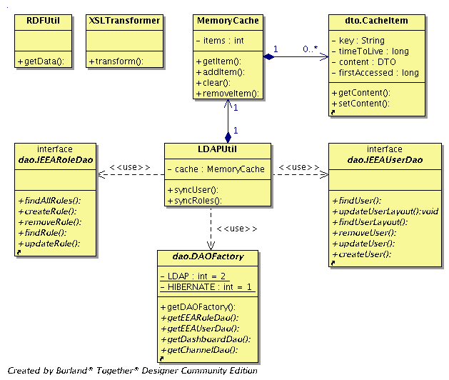
Figure 12 - The Utility module class diagram

XSLTransformer class
This utility class provides features for XSL transforming the data.

Attributes:
Methods:
- transform(String xst, Input Source inputSource, OutputStream result)
This method executes an XSL transformation on given input source by the inputSource parameter and writes the result to the result parameter. The method applies the style-sheet specified by the xst parameter.

RDFUtil class
This utility class is responsible for parsing the RDF formed data by using the Jena library.

Attributes:
Methods:
- getData(String rdf)
Parses the RDF provided by the rdf parameter and returns an instance of the DTO class containing the data in a property-value form grouped by subjects.

LDAPUtil class
This utility class is responsible for the managing of the LDAP data memory cache as will as for synchronization of data between the WDS and LDAP server.

Attributes:
- Cache
MemoryCache object that keep cached LDAP Roles and LDAP users. It is static attribute.
Methods:
- syncRoles()
Performs synchronization of all Roles and Users between the WDS and LDAP server. As result it returns list containing all existing roles.
- syncUser(EEAUser user)
Performs synchronization of all Users between the WDS and LDAP server. As result it returns Boolean value telling if specified user has been removed.

MemoryCache class
This class represents the Web Dashboards Caching mechanism.

Attributes:
- items
Represents list of cached items.
Methods:
- addItem(String key, DTO content, long timeToLive)
A static method that adds a new item to the memory cache.
It will create the instance of the CacheItem class and save it. This method expects three parameters; the parameter key represents the unique identifier of the new memory cache item, the parameter content represents the real content that is going to be cached and the parameter timeToLive represents how long the item will be alive inside the memory cache. In case of the ‘PUSH’ working channels timeToLive will be considered as infinite.
- removeItem(String key)
A static method that removes items from the memory cache as specified by the key parameter
- clear()
Invalidates the memory cache. In other words it removes all items contained inside the cache.
- getItem(String key)
A static method that returns an Object representing the item specified by the key parameter. This method will check if the timeToLive time is smaller than the current time minus the time when the content was last cached. If yes, the method will remove the specified item from the cache and will return NULL to the caller.

Data detailed design
This section aims at providing a detailed description of the physical data model of the REPORTNET Web Dashboards Service. All the WDS Database tables are described in detail in the tables bellow.

Database schema

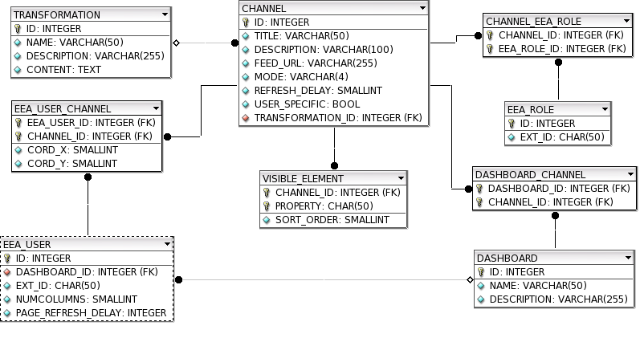
Figure 13 - The WDS Database physical data model diagram

CHANNEL_EEA_ROLE
ColumnName | DataType | PrimaryKey | NotNull | Flags | Default Value | Comment | AutoInc
CHANNEL_ID | INTEGER | PK | NN | UNSIGNED |  | The unique identifier of the referenced channel
EEA_ROLE_ID | INTEGER | PK | NN | UNSIGNED |  | The unique identifier of the referenced EEA Role

CHANNEL
ColumnName | DataType | PrimaryKey | NotNull | Flags | Default Value | Comment | AutoInc
ID | INTEGER | PK | NN | UNSIGNED |  | Unique identifier of the channel | AI
TITLE | VARCHAR(50) |  | NN |  |  | The title of the channel
DESCRIPTION | VARCHAR(100) |  |  |  |  | A description of the channel
FEED_URL | VARCHAR(255) |  |  |  |  | The URL of the external feed needed for channels that will work in pull mode
MODE | VARCHAR(4) |  | NN |  |  | A term representing the working mode of the channel. It is allowed to be 'PUSH' or 'PULL'
REFRESH_DELAY | SMALLINT |  |  | UNSIGNED |  | A number of seconds that need to expire before a new pulling for the channel occurs.
USER_SPECIFIC | BOOL |  | NN |  | FALSE | A logical value representing if this channel presentation is related to EEA Users
TRANSFORMATION_ID | INTEGER |  | NN | UNSIGNED |  | The unique identifier of the referenced transformation

DASHBOARD
ColumnName | DataType | PrimaryKey | NotNull | Flags | Default Value | Comment | AutoInc
ID | INTEGER | PK | NN | UNSIGNED |  | The unique identifier of the dashboard | AI
NAME | VARCHAR(50) |  |  |  |  | The name of the dashboard
DESCRIPTION | VARCHAR(255) |  |  |  |  | The description of the dashboard

DASHBOARD_CHANNEL
ColumnName | DataType | PrimaryKey | NotNull | Flags | Default Value | Comment | AutoInc
DASHBOARD_ID | INTEGER | PK | NN | UNSIGNED |  | The unique identifier of the referenced dashboard
CHANNEL_ID | INTEGER | PK | NN | UNSIGNED |  | The unique identifier of the referenced channel

EEA_ROLE
ColumnName | DataType | PrimaryKey | NotNull | Flags | Default Value | Comment | AutoInc
ID | INTEGER | PK | NN | UNSIGNED |  | The unique identifier representing the EEA Role | AI
EXT_ID | CHAR(50) |  | NN |  |  | External Unique identifier representing the EEA Role at EEA LDAP

EEA_USER
ColumnName | DataType | PrimaryKey | NotNull | Flags | Default Value | Comment | AutoInc
ID | INTEGER | PK | NN | UNSIGNED |  | Unique identifier of the EEA User | AI
DASHBOARD_ID | INTEGER |  |  | UNSIGNED |  | Unique identifier of the referenced dashboard
EXT_ID | CHAR(50) |  | NN |  |  | External unique identifier representing an EEA User at EEA LDAP
NUMCOLUMNS | SMALLINT |  | NN | UNSIGNED |  | The number representing actual number of columns on the dashboard page where portlets will be placed
PAGE_REFRESH_DELAY | INTEGER |  | NN | UNSIGNED | 60 | The number representing interval for the automatic refresh of the EEA User dashboard view

EEA_USER_CHANNEL
ColumnName | DataType | PrimaryKey | NotNull | Flags | Default Value | Comment | AutoInc
EEA_USER_ID | INTEGER | PK | NN | UNSIGNED |  | The unique identifier of the referenced EEA User
CHANNEL_ID | INTEGER | PK | NN | UNSIGNED |  | The unique identifier of the referenced channel
CORD_X | SMALLINT |  |  | UNSIGNED |  | A number representing the column on the users dashboard view at which the channel will appear
CORD_Y | SMALLINT |  |  | UNSIGNED |  | A number representing the row on the users dashboard view at which the channel will appear

TRANSFORMATION
ColumnName | DataType | PrimaryKey | NotNull | Flags | Default Value | Comment | AutoInc
ID | INTEGER | PK | NN | UNSIGNED |  | Unique identifier of the transformation | AI
NAME | VARCHAR(50) |  |  |  |  | The name of the style-sheet
DESCRIPTION | VARCHAR(255) |  |  |  |  | The description of the style-sheet
CONTENT | TEXT |  |  |  |  | A text representing actual XSL

VISIBLE_ELEMENT
ColumnName | DataType | PrimaryKey | NotNull | Flags | Default Value | Comment | AutoInc
CHANNEL_ID | INTEGER | PK | NN | UNSIGNED |  | Unique identifier of the referenced channel
PROPERTY | CHAR(50) | PK | NN |  |  | The unique name of the RDF predicate
SORT_ORDER | SMALLINT |  |  | UNSIGNED |  | A number representing sort order of the visible element

Deployment view
The REPORTNET Web Dashboards Service UML deployment diagram depicts a static view of the run-time configuration of processing nodes and the components that run on these nodes. In other words, the deployment diagrams show the hardware for the WDS, the software that is installed on that hardware, and the middleware used to connect the physically distinct machines to one another.

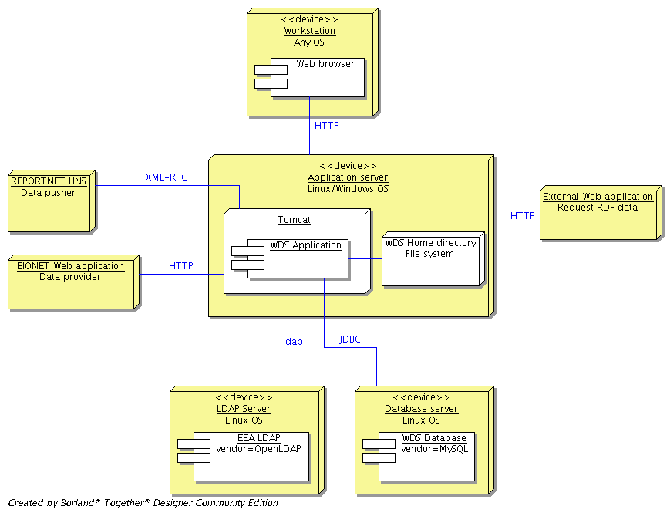
Figure 14 - The WDS Deployment diagram

Application server
It represents a server device which is running under Red Hat Enterprise Linux. In case of standalone WDS installations, this device can run under Linux or MS Windows since the Apache foundation is providing Tomcat installations for these OSs. The Tomcat application server will be installed on this device. Deployment of the REPORTNET Web Dashboards Service will take place under this Tomcat instance. The Tomcat instance will handle all communication initiated from the outside world. This includes HTTP requests, as well as XML-RPC calls. As shown in Figure 14 the WDS application will communicate with the LDAP and Database server.

Database Server
This is a server device running under Red Hat Enterprise Linux. In case of standalone WDS installations, this device can run under Linux or the MS Windows since MySQL foundation is providing MySQL Db Server installations for these OSs. MySQL database version 4.1 will be installed on this device. The WDS database will be deployed under this MySQL installation.

LDAP Server
This server device represents the existing informational structure of the EEA. It keeps the OpenLDAP server used as credentials storage. The WDS application will use it in order to authenticate users accessing the web site, as well as to keep consistency of data between the WDS Database (WDS Database on the figure above) and the EEA LDAP.
Organizational stakeholders who will install standalone WDS application will be able to use the same EEA LDAP server, but they can also use another LDAP server installed at their premises. The only important rule that has to be respected is that they will need a LDAP version 3 compatible LDAP server.

Workstation
A personal computer used by the users who want access to the WDS application. The installed component which will interact with the WDS shall be some Internet browsers as described in the FSD document.

EIONET Web application
It is software that lives outside the WDS. It may be located inside the EEA intranet structure; it may even be some remote resource accessing the WDS through the Internet.
The following list represents two types of the EIONET web applications that may communicate with the WDS:
- Data pushers. This type of the EIONET Web applications will push data to the WDS by using XML-RPC. This web application will mainly be the REPORTNET Unified Notification Service.
- Data providers. This type of the EIONET Web applications will provide data to the WDS in the RSS/RDF format. By using created channels the WDS will pull data from this kind of applications.

External web application
It represents software outside the WDS that may require receiving data from the WDS. Since the WDS will expose this data as RDF, external web applications will use the HTPP protocol to achieve their goals.

Appendix A - Interactions diagrams
Interfaces described in the section 4 will be used to allow interaction between system modules and interactions between external systems and the WDS.
The following sequence diagrams show these interactions in order accomplish system functions.

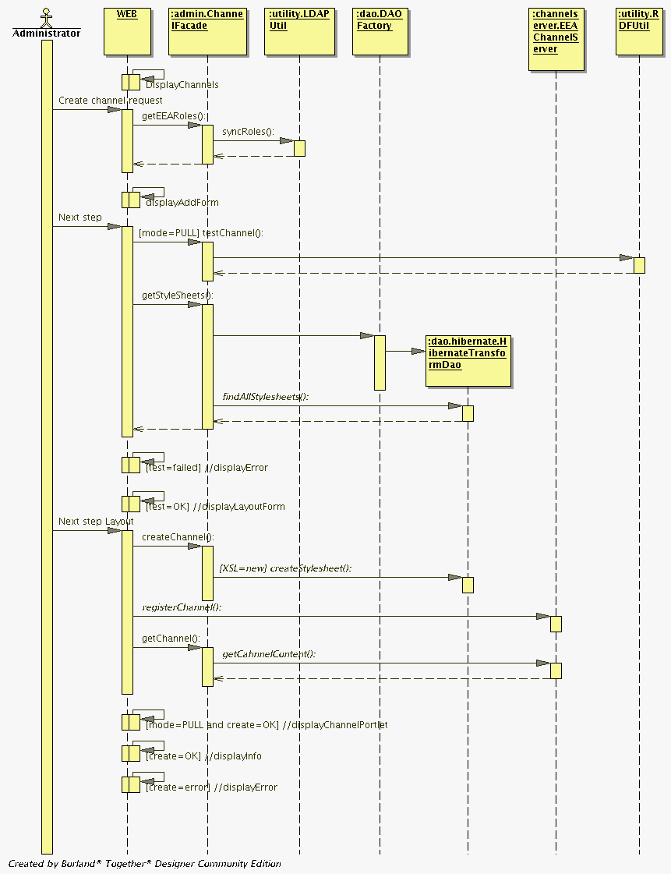
Figure 15 - Create new channel sequence diagram
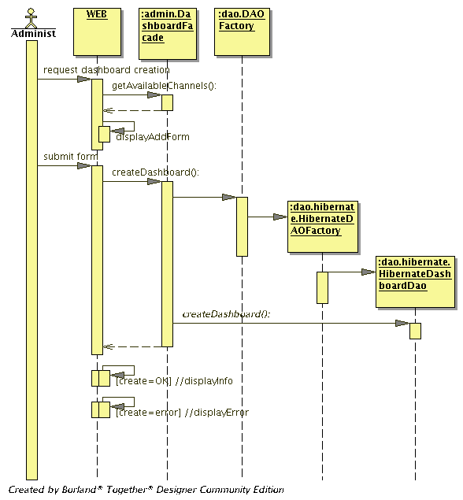
Figure 16 - Create dashboard profile sequence diagram

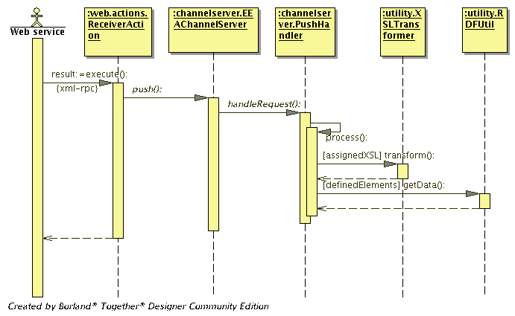
Figure 17 - Push RDF data to the WDS sequence diagram

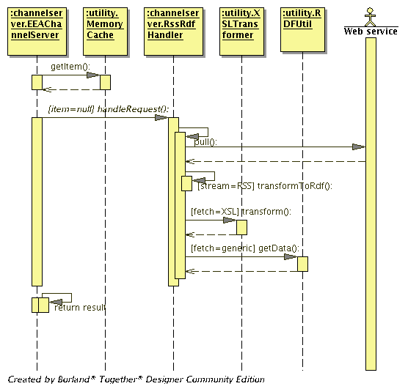
Figure 18 - Pull RSS/RDF data from the external web service sequence diagram

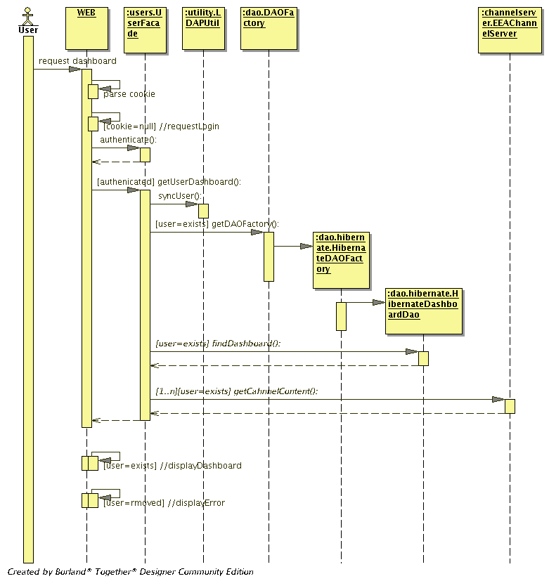
Figure 19 - View dashboard sequence diagram

END OF DOCUMENT

Action: I = Insert; R = Replace; C = Creation
It is important to stress that the REPORTNET Web Dashboards Service will be developed and tested with the aforementioned external libraries.
For more info please see: Web-Tier Application Framework Design
For more info please see: http://www.javaworld.com/javaworld/jw-08-2003/jw-0829-designpatterns.html
For more info please see: http://java.sun.com/blueprints/corej2eepatterns/Patterns/DataAccessObject.html
This file configures Hibernate. It effectively tells Hibernate how it should obtain JDBC connections and what mapping files it should use.
These files contain the metadata required for the object/relational mapping. The metadata includes the declaration of persistent classes and the mapping of properties to database tables (columns and foreign key relationships to other entities).

